# [‘Law & Order’ Crossover Premiere Ratings Beat Out Previous Seasons As Streaming on Peacock Increases (EXCLUSIVE)](https://variety.com/2022/tv/news/law-and-order-premiere-ratings-nbc-peacock-svu-1235392106/)

**By** [**Selome Hailu**](https://variety.com/author/selome-hailu/)

Plus Icon

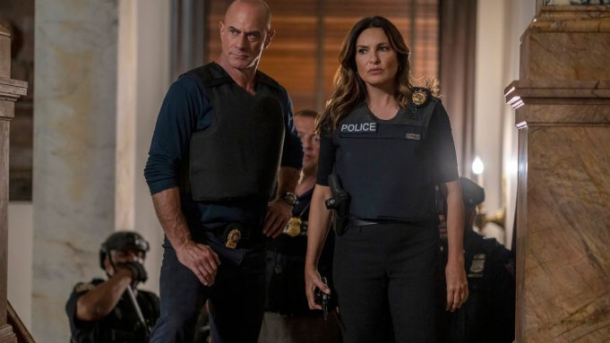

Zach Dilgard/NBC

[NBC](https://variety.com/t/nbc/)’s three-hour “[Law & Order](https://variety.com/t/law-order/)” crossover premiere event was the most-watched and highest-rated program the night that it aired, according to Live + 3 data exclusively obtained by *Variety*.

Airing from 8-11 p.m. on Sept 22, the crossover marked the premiere of Season 22 of the “Law & Order” flagship series, Season 24 of “[Law & Order: Special Victims Unit](https://variety.com/t/law-order-special-victims-unit/)” and Season 3 of “Law & Order: Organized Crime.” When accounting for three days of viewing, each of the three season premieres matched or exceeded the average rating and total viewership of the last four episodes of their previous seasons, respectively.

“Law & Order,” the first of the bunch, landed a 1.0 rating in the key adults 18-49 demographic and 6.8 million total viewers through three days of measurement — the best performance of a “Law & Order” episode since Season 21 debuted in February. Compared to Episodes 7-10 of “Law & Order” Season 21, the series’ four previous episodes, this marks a 36% increase in rating and a 20% increase in total viewership.

## **Related Stories**



[VIP+](https://variety.com/vip/2022s-last-hopes-box-office-projections-for-avatar-2-black-adam-black-panther-2-1235388447/)

### [**2022’s Last Hopes: Box Office Projections for ‘Avatar 2,’ ‘Black Adam,’ ‘Black Panther 2’**](https://variety.com/vip/2022s-last-hopes-box-office-projections-for-avatar-2-black-adam-black-panther-2-1235388447/)



### [**‘House of the Dragon’ Viewers Outraged Over Scenes Too Dark to See, HBO Defends Them as ‘Intentional Creative Decision’**](https://variety.com/2022/tv/news/house-of-the-dragon-viewers-outraged-scenes-too-dark-1235391259/)

In the 9 p.m. timeslot, Live + 3 data for the Season 24 premiere of “Law & Order: Special Victims Unit” was even with the series’ four most recent episodes: an 18-49 rating of 1.4 with 7.7 total million viewers.

Closing “Law & Order” night at 10 p.m., “Organized Crime” posted a 1.2 key rating, up 8% from its four most recent episodes, and 7.3 million total viewers, up 27%.

The audience of [Dick Wolf](https://variety.com/t/dick-wolf/)’s famous franchise continues to grow, and while the numbers above point to an increase in viewership compared to last season, they also indicate how much of the franchise’s fans tune in via DVRs, on-demand and other digital platforms instead of during the initial airings on NBC. The day after the “Law & Order” premiere, [it was reported](https://variety.com/2022/tv/news/dick-wolf-law-order-chicago-fbi-fall-ratings-premiere-1235382457/) according to Live + Same Day data that the flagship series nabbed a 0.6 rating and 4.7 million viewers among adults 18-49, “Special Victims Unit” made a 0.69 with 5.5 million viewers and “Organized Crime” landed at a 0.62 with just under 5 million viewers. The new ratings and total tallies after three days of measurement, all at a 1.0 or above and all with 6.8 million total viewers or above, show solid jumps from where they started.

NBC also confirmed to *Variety* that streaming consumption for the season premieres of the flagship and “Organized Crime” both exceeded most episodes from late last season — a significant feat, as last season’s streaming viewership included both Hulu and Peacock, while the shows now live on Peacock exclusively. The network also says that when comparing last season’s Peacock viewership to this season’s, all three “Law & Order” series saw 6-8x increases, and that the three episodes that made up the crossover premiere are now the top NBC episodes on Peacock.